Using Event Filter and Event List Properties

Event Filter
Click the Right Mouse Button, Select Display/Hide Toolbar.

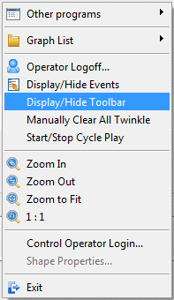

Click PecStar < Configurations <System Options.

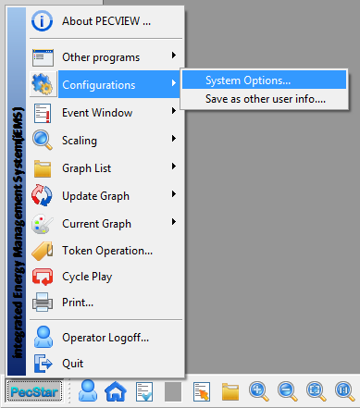

Select Event Filter

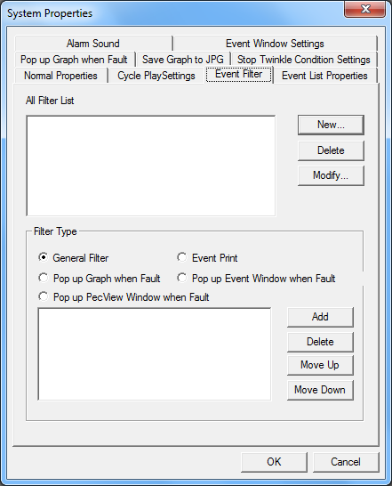

In the Filter Properties Window, Click New

Name: You can give a name for the filter, such as “35kV Incomer 1 DI ON Alarm”.

Station: You must choose a station for the filter.

Site, Device: Choose a device by Selecting Station>site>Device. If you don’t select these two check boxes, it means all sites and all the devices of the station are selected.
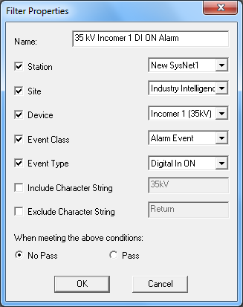

Event Class: There are four classes of Event in PecStar. You can select Normal, Alarm, Fault and Other Event. Here we choose Alarm Event as an example.

Event Type: Choose an event type according to the event’s classification. Such as Device Exceed Limit, Control and Adjust, Digital In ON/OFF, etc. You should choose the right Event Class. Actually you can check the event class in PecEvent.

See below, the Event Type indicates the Event Class.

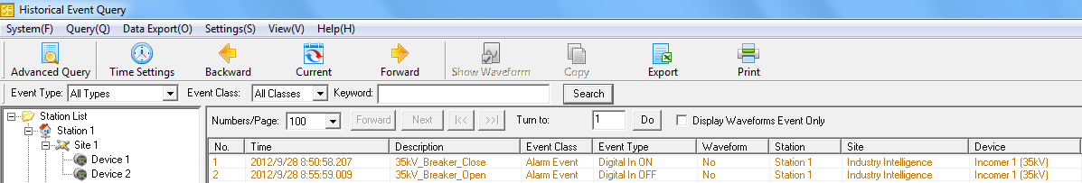

Event Class and Event Type are also optional. If you don’t select these checkbox, then it means the filter will ignore the class/type of the alarm.

Include Character String: If the Alarm Information contains the string you specified, the alarm will pass/not pass.

Exclude Character String: If the Alarm Information contains the string you specified, the alarm will pass/not pass.

No pass/pass: When the above conditions are satisfied, the events will not pass/pass the filter.

No Pass means the event will be filtered.

Filter Type

Here you can choose a filter result, you need to select one filter in the All Filter List, then select a Filter Type (the result), then click Add and click OK.
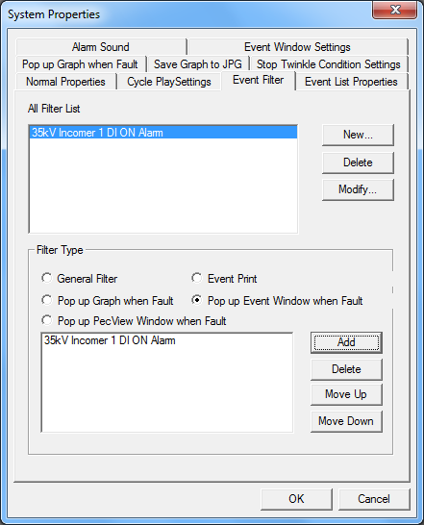

General Filter: Just Filter the events you want and you don’t want.

Event Print: When the system has events in line with the filter conditions, the events will be output and implement automatic printing line by line.

Select System Properties< Normal Properties< Enable Auto-Print Event (only for dot-matrix printer).
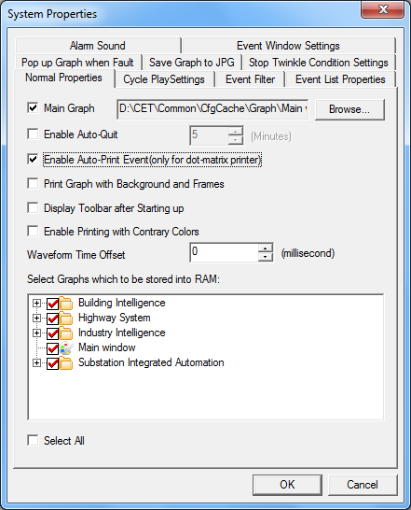

Pop up Graph when Fault: You need to configure it in System Properties<Pop up Graph when Fault, and define the conditions.

Pop up Event Window when Fault: If you select this one, the event window will automatically show when there is a fault happens.

Pop up PecView Window when Fault: If this one is selected, then the PecView Window will automatically pop up. For example, your current window is the IE, it will pop up the PecView window when Fault.

Event List Properties Setup

The Event List Properties Setup is very simple. You can setup the foreground color and background color for different event, and the font and size for confirmed and unconfirmed event, event number, etc.

For example, we setup as following:
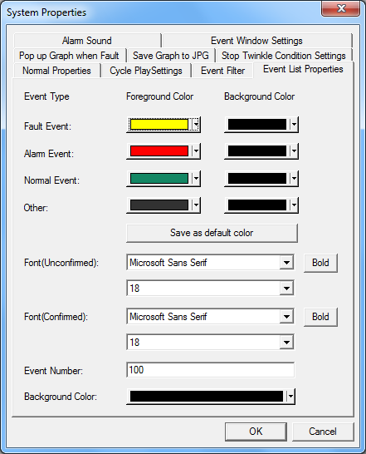

Then the result is:
